**Biographical Details**

Franz Kafka was born 3 July 1883 to a bourgeois family in Prague, the Czech capital that in the late nineteenth century belonged to the Austro-Hungarian Empire. Although his nationality was therefore Austro-Hungarian, Kafka’s parents, Hermann Kafka and Julie Lowy were Jewish, and under the reign of Franz Josef I, Austrian Jews were widely regarded as second-class citizens. As a Jewish family growing up in Czech-speaking Prague, Hermann Kafka strongly insisted that his children be raised to speak and act German, the *de facto* language and identity of social and cultural prestige in Prague during this period. While Kafka exhibited a keen interest in literature and art from a very young age, his notoriously overbearing father was insistent that he should receive education and training for a professional or administrative career, which would allow him to provide his future family with the same level of upper-middle class affluence that Hermann had provided for Franz. Kafka reluctantly capitulated, and on 18 June 1906 he successfully completed a Doctorate in Law from the Ferdinand-Karls University in Prague.

In late 1906 Kafka accepted a short-term, unpaid internship working as a law clerk for the court, which was a typical (and obligatory) starting place for anyone aspiring to a legal or administrative career with the government. When he finished his stint working as a clerk he took up paid, though still unfavorable employment for an Austrian-Italian insurance company based in Prague. Despite his high hopes of being transferred out of the Prague office to a more exotic location elsewhere in Europe, Kafka remained, unhappily, with the firm until the summer of 1908, when, with the help of an old friend from school, he secured new and permanent employment with the Workers’ Accident Insurance Company for the Kingdom of Bohemia. Alain Supiot explains that by “visiting factories, meeting men injured at work, wrestling with a bureaucracy that sought ways to avoid compensating them, [Kafka] had an everyday experience of injustice” (99). Kafka’s intimate proximity to bureaucratic injustice, Supiot continues, “had a powerful influence on his literary work” (99).

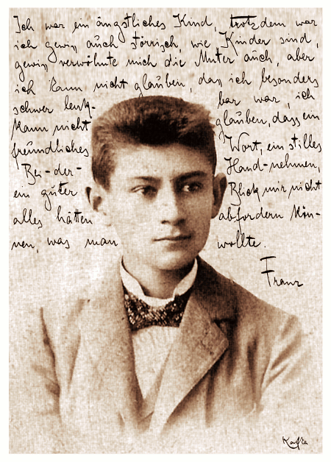

**Kafka’s Life and Work in Prose: Novels and Short Stories**

During his lifetime, Kafka was exclusively known for his short story writing, which included famous works such as “The Metamorphosis”, “In the Penal Colony”, “A Country Doctor”, “Before the Law”, and “A Hunger Artist”. It is no coincidence that much of Kafka’s short fiction is set around the humdrum world of office functionaries and bureaucrats, the world that occupied Kafka during the day and therefore distracted him from the considerably more important and spiritually-enriching work of writing and literature. In a letter to Felice Bauer (Kafka’s fiancée for a short time) Kafka notes that his office desk “is littered with a chaotic pile of papers and files; I may just know the things that lie on top, but lower down I suspect nothing but horrors” (*Letters to Felice* 84). As was the case in works like “The Metamorphosis”, in which the protagonist Gregor Samsa suddenly and famously wakes up one morning to the horrifying reality that he has become an insect, Kafka’s writing was interested in exploring precisely the “lower down” parts of experience and consciousness, those parts of the soul and of the world where humanity and civilization break down and the social and psychological façades that hold them precariously together begin to dissolve.

It is safe to say that without the friendship and constant encouragement of Max Brod, Kafka’s literary output would not have been nearly as prodigious as it would undoubtedly become. From the very beginning of Kafka’s career in literature, Brod worked tirelessly to gain Kafka recognition in the world of letters and regularly acted as Kafka’s unofficial agent in securing opportunities for publication. Whenever Kafka’s confidence as a writer starting to decline, as it often did for reasons owing to his intensely self-critical and depression-prone disposition, Brod often and ingeniously proposed ways for Kafka to continue writing. After Kafka’s death, Brod was placed into the unenviable position of being the executor (literally) of Kafka’s literary estate. Amongst Kafka’s miscellaneous literary remains was a letter addressed to Brod, which included instructions on how his unpublished work was to be handled: “Dearest Max, my last request: Everything I leave behind me […], in the way of diaries, manuscripts, letters (my own and others’), sketches, and so on, to be burned unread” (“Postscript” 256-266). Generations of readers and critics are eternally grateful to Brod for refusing to carry out Kafka’s draconian instructions.

Amongst Kafka’s posthumously published works that Brod actively labored in compiling and readying for publication are the three novels *Amerika*, *The Trial*, and *The Castle*. Kafka began work on *Amerika* in late 1911 only to abandon it completely by the summer of 1914. In comparison to the more critically acclaimed novels *The Trial* and *The Castle*, *Amerika* (*The Missing Person*) can more easily be classified as a work of literary realism that negotiates (with uncharacteristic humor) the tension between freedom, servitude, exploitation, exile, and hope that the narrative’s solitary protagonist, Karl, is compelled to confront after he is obliged to emigrate from Europe and begin a new life in America. In the writing of *The Trial* and *The Castle*, on the other hand, Kafka decided to inscribe his protagonists in more abstract and recognizably modernist spaces, which did not bear any immediate connection to real historical times or geographical locations. The central setting of *The Trial*, for instance, is the nightmarish interiority of the institution of the Law that the text’s protagonist, Josef K., is condemned to inhabit after being arrested (while remaining, paradoxically, free to continue living his everyday life) and indefinitely put on trial without any straightforward indication of the crime he has purportedly committed. Kafka’s treatment of the inaccessibility and arbitrariness of the Law resonated strongly with twentieth century readers and the pervasive experience of bureaucratic rationality in the age of modernity. While there has been much critical debate over the significance of the interminable dead-ends that Kafka consistently placed in obstruction of his protagonists’ quest for meaning and knowledge inside the space of the text, it is clear that the uncompromising ambiguity that surrounds Kafka’s compositional choices affords his work a special status in the history of literature and thought.

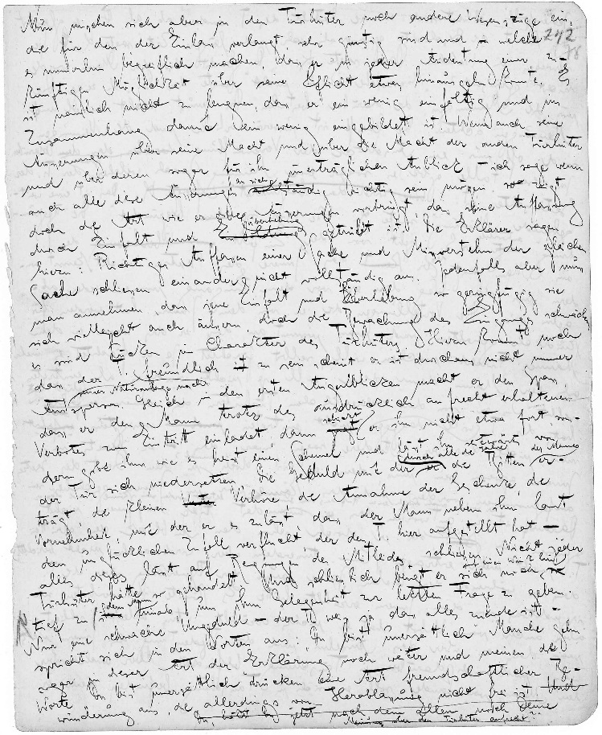

**References and Further Reading**

*Works Cited*

Brod, Max. “Postscript to the First Edition (1925)”. *The Trial*. Trans. Willa and Edwin Muir. New York: Schocken Books, 1968. 264-272.

Kafka, Franz. *Letters to Felice*. Ed. Erich Heller and Jürgen Born. Trans. James Stern and Elizabeth Duckworth. New York: Penguin Books, 1978.

--. *Letters to Friends, Family, and Editors*. Trans. Richard and Clara Winston. New York: Schocken Books, 1977.

Supiot, Alain. “Grandeur and Misery of the Social State”. *New Left Review*. 82 (2013): 99-113. Print.

*List of Selected Works (Kafka)*

*Amerika: The Missing Person.* Trans. Mark Harman. New York: Schocken Books, 2008.

*The Castle.* Trans. Mark Harman. New York: Schocken, 1998.

*The Complete Stories*. Ed. Nahum N. Glatzer. New York: Schocken, 1995.

*Diaries: 1910-1923.* Ed. Max Brod. Trans. Joseph Kresh and Martin Greenberg, with cooperation of Hannah Arendt. New York: Schocken Books, 1976.

*The Metamorphosis.* Ed. and Trans. Stanley Corngold. New York: W.W. Norton, 1996.

*The Trial*. Trans. Breon Mitchell. New York: Schocken Books, 1998.

*List of Selected Critical Works and Biographies*

Adler, Jeremy. *Franz Kafka*. New York: Overlook, 2004.

Brod, Max. *Franz Kafka: A Biography*. Trans. G. Humphreys Roberts and Richard Wilson. New York: Schocken Books, 1963.

Deleuze, Gilles and Felix Guattari. *Kafka: Toward a Minor Literature*. Trans. Dana Polan. Minneapolis: University of Minnesota Press, 1986.

Flores, Angel, ed. *The Kafka Debate: New Perspectives for Our Time*. New York: Gordian, 1977.

Preece, Julian, ed. *The Cambridge Companion to Kafka*. Cambridge: Cambridge University Press, 2001.